3.5" External SATA Hard Disk ENCLOSURE

Simply Add Your Own 3.5" Hard Disk
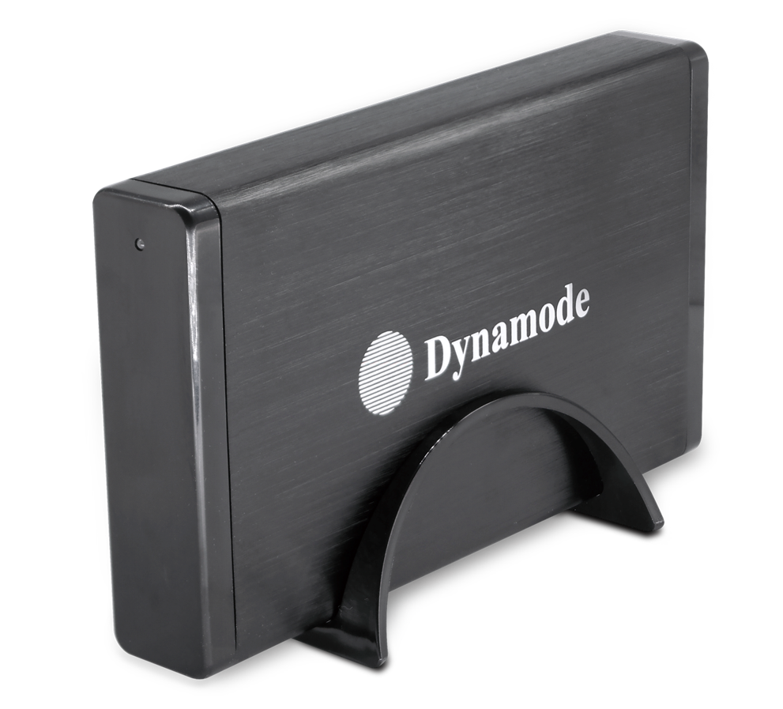

DESCRIPTION
Are you looking for a high-performance but fully backward compatible external hard disk enclosure for your desktop, notebook or other computing device? Do you need the extra data transfer performance that USB3.0 can give you for streaming movies without buffering or copying large digital images to and from your computer?
The USB3.0-HD-3.5S-M is your ideal desktop, server or media centre storage enclosure. Featuring a SuperSpeed USB3.0 interface which transfers data around x10 quicker than standard USB2.0. And if your computer only has USB2.0 at the moment, no problem, the enclosure is fully backward compatible with USB2.0 if required,.
Easy for anyone to use, simply connect your existing 3.5" SATA interface hard disk, connect up the supplied USB3.0/USB2.0 data cable and start using it in a few minutes. Can be deployed either horizontally or vertically on the desktop and comes with an external power supply as standard.
Fully Plug n' Play with WindowsTM including Windows10TM and Mac OS XTM operating systems.

FEATURES
Utilize your existing 3.5' Hard Disk or SSD
Ideal for WindowsTM or MacTM users
SuperSpeedTM USB3 - up to 5Gbps
No drivers needed - just plug and go
Backward compatible with USB2
Stylish, passive cooled design
External PSU supplied

SPECIFICATIONS
